Last time we looked at the grid stucture, now we are going to look at framesets! If you have used something HTML before, framesets should be very familiar to you. This tutorial might be too easy for you even so trying the advanced basic tutorial if you’ve worked with frames in html before.

Anyways, let’s get down what a frameset exactly is. A frameset is an flexible structure for you to make. With grids a lot of frames are bound to each other, which is not the case for framesets. With framesets you can create stuff like:

IMAGE 49:



On the top frame you could put buttons for example, and on the left side you could put a menu. Then in the middle you could have it display something else. Now let’s get start understanding how we make these slick structures.

Enable the mark variable in the create event of obj_uiZ_frame again by replacing:

[CODE]  
mark=false//b//mark

[/CODE]

With:

[CODE]  
mark=true//b//mark

[/CODE]

Now that we’ve replaced that we can see what we are doing.

**Creation of framesets.** A shall be created using:

* Uiz_frameset_create. (uiz_c(obj_uiZ_frameset) will work just as well).
* Some uiz_framedivision scripts with proper usage.
* Fixing the frameset using uiz_fixgeneralpos().

The first and last part should be pretty straight forward right now. The second thing you need to do is a little harder though, but it’s the step that will define what your frameset looks like.

Defining your frameset exists out of 2 different things: horizontal and vertical devisions. When doing a horizontal division, just think of a horizontal line (or multiple lines) cutting a frame into pieces. When doing a vertical division, do the same with vertical lines.

If you look at image 49, you can see that it exists out of 2 divisions, one horizontal and one vertical. If you look closely, you can also see some structure in it: The horizontal division has been done first, and then the vertical.

IMAGE 49:



Now let’s look at some functions. The function for a horizontal cut is **uiz_framedivisionhorizontal(object,divisionval,valuetype[px dp or fc],divisionval,valuetype[px dp or fc],........)**, and the one for a vertical cut is: **uiz_framedivisionvertical(object,divisionval,valuetype[px dp or fc],divisionval,valuetype[px dp or fc],........)** These functions return a **frameanchor**, which we’ll learn about later. These functions both take at least, but are not limited to 5 arguments. The first argument can refer to a few different objects: The frameset or a frame inside the frameset. What it can NEVER refer to are: frameanchors (what a divisionscript returns) or a frameset that already had a division. YOU CANNOT USE THIS FUNCTION ON A FRAMESET IF YOU’VE ALREADY MADE A DIVISION USING THAT FRAMESET.

Also, you’re not done with your divisions by just calling a uiz_framedivision… script. You need to “get” the newly created frames. With “getting” I mean getting an instance id of an frame, with which we can put objects inside our frames. For this you’ll need a **frameanchor.** Frameanchors act like in-betweens, an object which stitches the frames in your frameset together. It is not that important to have a very deep understanding of frameanchors, but they are needed for getting the frames in framesets. A frameanchors holds an array called “frameat” which starts counting from 0 and has all the instance id’s of all divisions. This is what you’ll be using frameanchors for.

Finally here is some example code:

EXAMPLE 37:

[CODE]

//init uiz

uiz_init()

//create frameset

frset=uiz_frameset_create()

//divide horizontally

div1=uiz_framedivisionhorizontal(frset,1,dp,1,xtra)

topbar=div1.frameat[0];

mainpart=div1.frameat[1];

//divide vertically

div2=uiz_framedivisionvertical(mainpart,0.1,fc,1,xtra)

leftframe=div2.frameat[0];

mainframe=div2.frameat[1];

uiz_fixgeneralpos(frset)

[/CODE]

IMAGE 50:

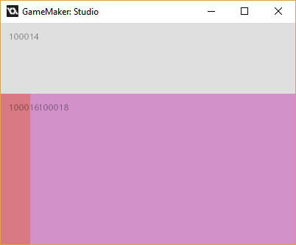

*\*mark frames is turned on here*

Now, the top frame is stored in a variable called “topbar” the left bar is stored in a variable called “leftframe” and the right frame is stored in a variable called “mainframe”. “div1” and “div2” refer to frameanchors in this code. You should NOT use the variable “mainpart” anymore, since it frame has been used someplace else in the frame structure. You don’t not exactly where. (This prevents having to delete an object, when a new one has to be created anyways.) Knowing what all of our variables do this, we can put a gradientsquare in the bottom-right frame by doing:

EXAMPLE 38:

[CODE]

//init uiz

uiz_init()

//create frameset

frset=uiz_frameset_create()

//divide horizontally

div1=uiz_framedivisionhorizontal(frset,1,dp,1,xtra)

topbar=div1.frameat[0];//the top frame

mainpart=div1.frameat[1];//this variable will be unusable after our second devision

//divide vertically

div2=uiz_framedivisionvertical(mainpart,0.1,fc,1,xtra)

leftframe=div2.frameat[0];//the left bar

mainframe=div2.frameat[1];//the big, bottom-right frame.

//fix our frameset

uiz_fixgeneralpos(frset)

//create a gradientsquare in the mainframe.

grad=uiz_c(obj_uiZ_gradientsquare)

//put it in the mainframe

uiz_setparent(grad,mainframe)

//fill the frame

grad.posinframex=uiz_fill;

grad.posinframey=uiz_fill;

//fix the gradient

uiz_fixgeneralpos(grad)

[/CODE]

This gives us:

IMAGE 51:

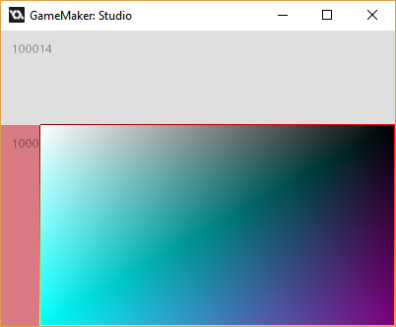

As you’ve seen in our examples, we can use “sizetypes” on framesets. Inside our uiz_framedivisionhorizontal/vertical script, we can give it “px”, “dp”, “fc”, and “xtra”, all of these work like explained in previous tutorials. What’s also nice about the uiz_framedivisionhorizontal/vertical functions, is that they support more than 2 frames. You might want to create a row of 3 frames, or 5 frames. The division functions supports as many frames as the amount of arguments game maker can handle for scripts. Just make sure that you specify both a size, and a sizetype for every frame. Here is an example, where we’re getting more frames from one division:

EXAMPLE 39:

[CODE]

//init uiz

uiz_init()

//create frameset

frset=uiz_frameset_create()

//divide horizontally

div1=uiz_framedivisionhorizontal(frset,1,dp,1,xtra)

topbar=div1.frameat[0];//the top frame

mainpart=div1.frameat[1];//this variable will be unusable after our second devision

//divide vertically

div2=uiz_framedivisionvertical(mainpart,0.1,fc,3,xtra,1,xtra)

leftframe=div2.frameat[0];//the left bar

mainframe=div2.frameat[1];//the big, bottom-right frame.

rightframe=div2.frameat[2];//an extra frame on the right, created by supplying more argumetns to uiz_framedivisionvertical

//fix our frameset

uiz_fixgeneralpos(frset)

grad=uiz_c(obj_uiZ_gradientsquare)

//put it in the mainframe

uiz_setparent(grad,mainframe)

//fill the frame

grad.posinframex=uiz_fill;

grad.posinframey=uiz_fill;

//fix the gradient

uiz_fixgeneralpos(grad)

[/CODE]

IMAGE 52:

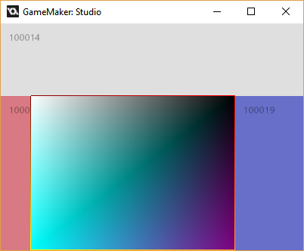

Now you should fully understand how to use framesets. There are a few more functions about which you can find more information in the manual/documentation. Those functions aren’t that important and you won’t be using them that often. You should by now be able to make structured ui’s. Next time we’ll talk about windows, another important feature of uiz. Just don’t forget to turn off markframes when you are not using it.